UP TO 100 HOURS OF WIRELESS GAMING
Sennheiser introduces the GSP 370

Sydney/Ballerup, October 9, 2019 – Experience exceptional sound quality for up to 100 hours with Sennheiser’s GSP 370 wireless gaming headset. It features a wireless low-latency connection, a convenient cable-free setup that allows great mobility and a clean desk. Jump into extended gaming sessions like no other with the Sennheiser GSP 370.

The GSA 370 dongle provides a wireless, low-latency connection to the headset to ensure a reliable transmission with near-zero delay. This makes the gaming headset an ideal match for games where fast response times are key. The USB dongle is compatible with PC, Mac®, and Sony PlayStation® 4.
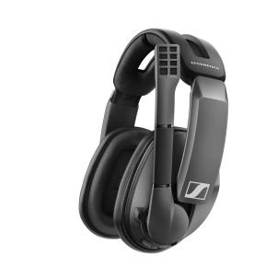 | The new Sennheiser GSP 370 features a low-latency connection as well as a long-lasting, integrated rechargeable battery. This results in a stable and lag-free sound with an exceptional battery life of up to 100 hours.

Sennheiser Gaming Suite allows individual sound adjustments on the PC
The GSP 370 over-ear headset is based on the same closed acoustic design as the award-winning GSP 300. Integrated digital sound processing enhances the audio experience giving users exceptional bass performance and acoustic clarity. For a more personalized sound experience, the Sennheiser Gaming Suite for Windows® offers various surround sound modes, an equalizer, microphone options, and ready-to-use presets for typical genres and occasions, allowing you to adjust the audio to your own preferences.

Like all other Sennheiser Gaming headsets, the GSP 370 features a broadcast quality noise-cancelling microphone, which actively minimizes background noise and can be muted by simply lifting the boom arm. The game audio is synchronized with the Windows® volume control and can be adjusted intuitively via an integrated volume wheel on the ear cup.
The GSP 370 microphone can be muted by simply lifting the boom arm. | 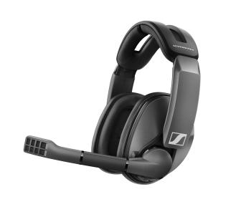

Battery life of up to 100 hours
Thanks to a low power consumption and a long-lasting integrated battery, the GSP 370 has an exceptional battery life of up to 100 hours: gamers who play six hours a week on average can game for four months with this wireless headset before having to recharge. The GSP 370 is charged over micro-USB (cable included in the box) and can be used while charging.

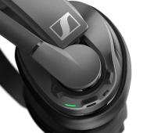 | The GSP 370 has an exceptional battery life of up to 100 hours. It is recharged via an included micro-USB cable.

Strong focus on wearing comfort
Sennheiser has designed the GSP 370 with a strong focus on wearing comfort. The split, padded headband reduces pressure on the skull while memory foam ear cushions provide a comfortable fit and isolate ambient noise. A clever ball-joint hinge automatically angles the ear cups to suit the shape of your face, while the ear cups themselves are shaped and angled to perfectly fit around the human ear. This makes the headset comfortable to use even during extended gaming sessions.

The headband is split and reduces pressure on the skull. Memory ear cushions isolate ambient noise and provide a comfortable fit.

"With the GSP 370, we are adding another wireless gaming headset to our portfolio that not only features our highly praised low-latency connection, but also provides an impressive battery life. All this is rounded off with the typical Sennheiser virtues: high wearing comfort, premium craftsmanship and an exceptional audio experience", says Andreas Jessen, Director of Product Management Gaming at Sennheiser Communications A/S.

Price and availability
The Sennheiser GSP 370 is now available in Sennheiser's web shop at a recommended retail price of AU $349.95. If you purchase the gaming headset from the Sennheiser website, you will also receive the GSA 50 headset hanger (value: AU $54.95) free of charge.

about Sennheiser
Shaping the future of audio and creating unique sound experiences for customers – this aim unites Sennheiser employees and partners worldwide. Founded in 1945, Sennheiser is one of the world’s leading manufacturers of headphones, loudspeakers, microphones and wireless transmission systems. Since 2013, Sennheiser has been managed by Daniel Sennheiser and Dr. Andreas Sennheiser, the third generation of the family to run the company. As part of the Sennheiser Group, Sennheiser Communications A/S is a joint venture specialized in wireless and wired headsets and speakerphones for contact centers, offices and Unified Communications environments as well as headsets for gaming and mobile devices. In 2018, the Sennheiser Group generated turnover totaling €710.7 million. www.sennheiser.com

Global Press Contact Local Press Contact

Poppy Byron Heather Reid
Sennheiser Communication A/S Sennheiser Australia Pty Ltd
PR Manager, Gaming Communications Manager
T: +45 7242 1700 T: +61 448 119 609
poby@senncom.com heather.reid@sennheiser.com

